
Amazon Music Clustering, miniproject – 4
Jessica Sriramula

Introduction:
With millions of songs available on platforms like Amazon, manually categorizing tracks into genres is impractical. The goal of this project is to automatically group similar songs based on their audio characteristics using clustering techniques and exporting my analysis into a new dataset file and showcasing my results in streamlit application. By analyzing patterns in features such as tempo, energy, danceability, and more, my goal is to develop a model that organizes songs into meaningful clusters, potentially representing different musical genres or moods—without any prior labels. The main uses of this project are to automatically group songs that sound similar to enhance playlist generation, suggest similar tracks to users based on their preferred audio profile, help artists and producers identify competitive songs in the same audio cluster and streaming platforms can use clusters to analyze user listening patterns and optimize recommendations or promotions.
Steps used:
For this project, I have utilized the K-means algorithm along with the DBSCAN algo to treat the outliers for optimizing the overall performance of the K-means model, to organize songs into their meaningful clusters based on the different genres or moods of the songs. Because K-means algo is highly sensitive to outliers and not treating them can lead to wastage of the clusters where the model creates entire clusters for outliers and centroid shifting where the cluster centers pull physically towards to the outlier, this can affect the overall efficiency of the K-means model, for this reason I have utilized the DBSCAN algo method into my code pipeline in vscode. In each step of my code, I have utilized the cleaned dbscan dataset as this dataset has been cleaned and treated with outliers and all the EDA steps.

I firstly loaded the dataset in vscode then I explored the amazon music dataset checking for duplicate values in each of the columns, missing values, outliers(for followers column and duration_ms column only) via boxplots as you can see below the outlier plot, and dropped unnecessary columns such as track_name, name_artists and track_id as they are not needed for clustering. I also checked the data types for each column to make sure everything is in number form, but for this analysis the name_song and id_artists are not converted into integers, but release_date is converted into a numeric year because forcing categorical identifiers into integers introduces flawed mathematical relationships that will corrupt my K-means results.
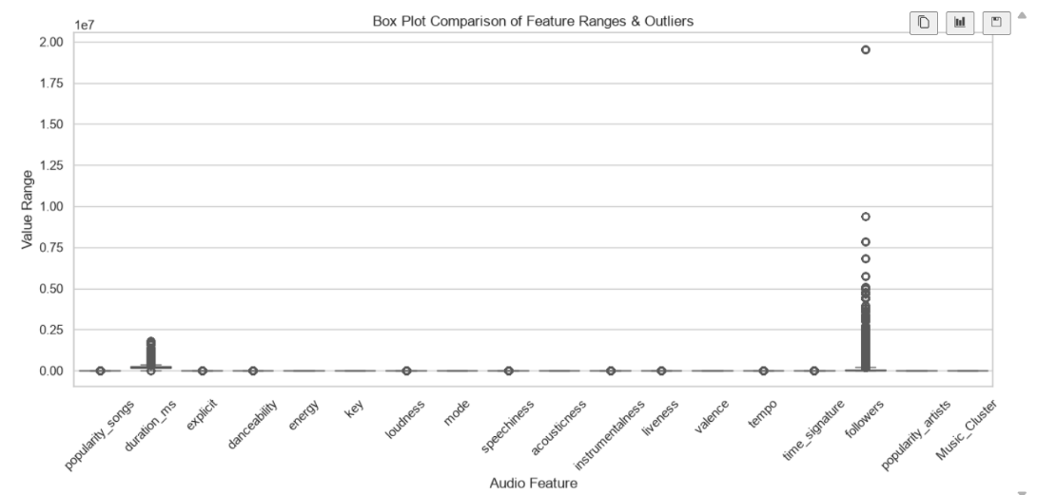
Boxplot for outliers.

Then I visualized the distributions of the data in each of the columns through the histogram graphs and checked for normal distributions of the data and understanding any variations in the data, after this then I used the standard scaler to bring all the necessary data in particular columns such as danceability, energy, loudness, speechiness, acousticness, instrumentalness, liveness, valence, tempo, duration_ms to the same scale. As the data distributions is varied as shown below from my visualisations, I have used the standard scaler to scale the values of the features to the same value so it doesn’t affect the optimization k-means model when applied.

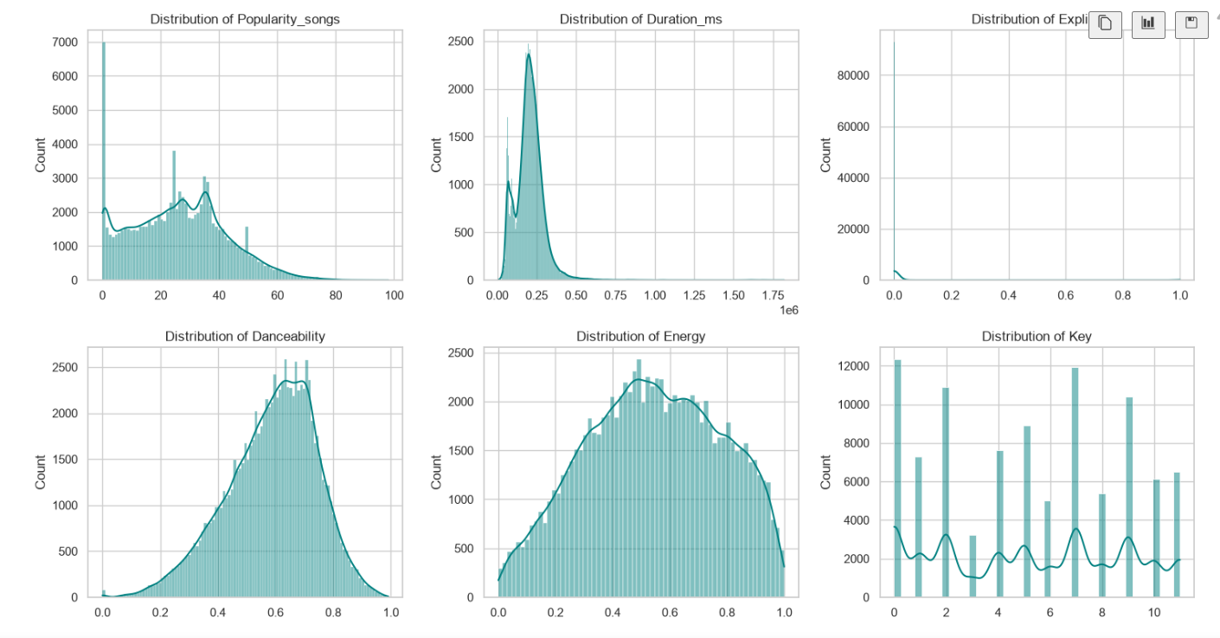
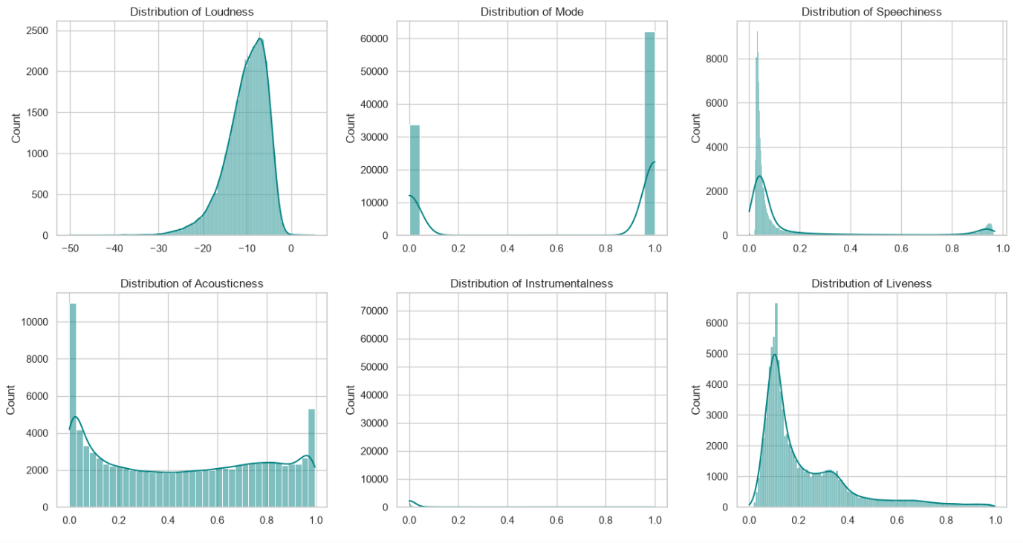

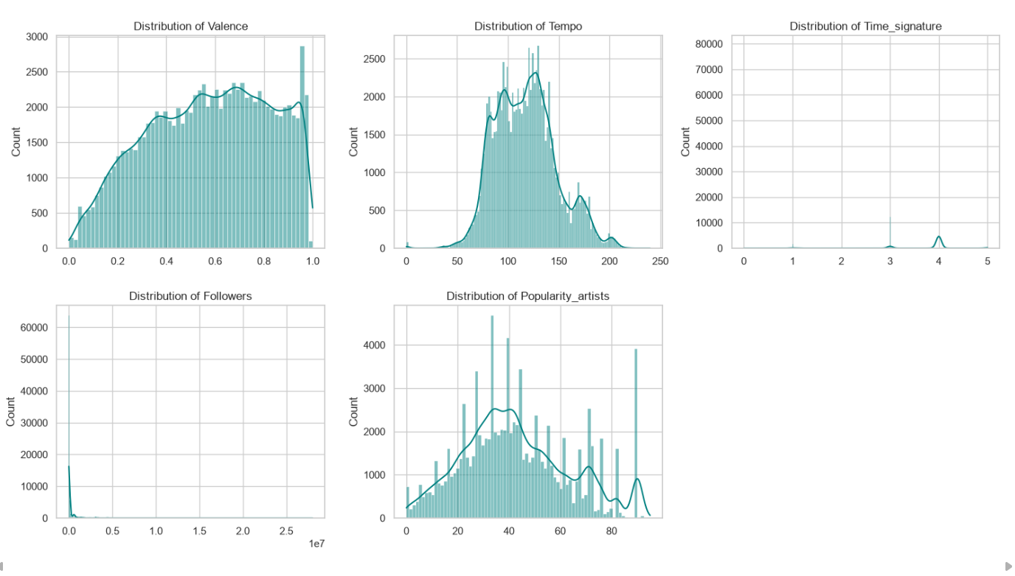
All visualizations of the distributions of the data variations.

Then I used the PCA method to reduce the dimensionality of the ten columns danceability, energy, loudness, speechiness, acousticness, instrumentalness, liveness, valence, tempo, duration_ms and plotting these features onto a 2D scatter plot to see if my K-means clusters form the correct visual shapes of clustering. PCA is needed because it combats the curse of dimensionality because if too many features are added into the dataset model, it can cause K-means to lose its ability to distinguish between the clusters, that’s why PCA condenses these features into a few highly informative components, restoring the accuracy of the distance metrics.

After this, I used the clustering techniques k-means elbow method and silhouette score to determine the best number of cluster value k, from this I found out that the best ‘k’ value is 4, and then I applied this value of k to the dataset and assigned the clusters to the dataset, for 0 cluster group there are 30021 songs and 1 cluster group there are 18717 songs and for cluster 2 group there are 12293 songs, and for the cluster 3 there are 34597 songs, this is how the k value has been assigned into the clusters for the dataset based on the ten features.
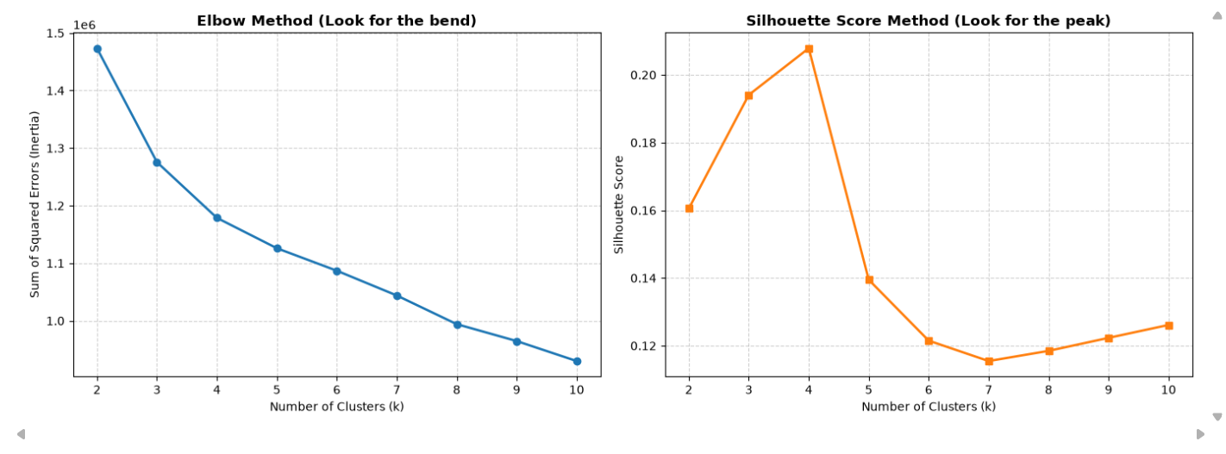
According to the elbow method and silhouette score, k=4 has been taken from the graphs as the best k value.

Then, I checked how well the clustering algorithm worked to understand the nature of each cluster using the silhouette score, inertia(k-means) and the davis-bouldin score, and found out that the silhouette score is 0.3656 which means most songs are assigned to the correct cluster, and there is a clear separation between the groups, the davis-bouldin score is 0.9979 which means that mathematically the distance between the different song groups is greater than the internal spread inside each group therefore my clusters are cleanly isolated from one another and not overlapping or messy and the inertia value is 321626 which suggests that my clusters are compact and dense. Here below are how the clusters are being assigned based on each song feature in my vscode, from this we can see that cluster 0 has a high acoustic value and moderate energy value which means that this cluster is a energy tracks music, cluster 1 has a high danceability value and a high energy value which means that this cluster is a party music, cluster 2 has high speechiness value and a high liveness values which means that this cluster is a chill acoustic music and the last cluster 3 has the lowest danceability value and the lowest energy value which means that this cluster is deep ambient music. This clustered analysis I have created and saved into a dataset called “clustered_music_dataset.csv” in vscode which I have attached in my github repository.
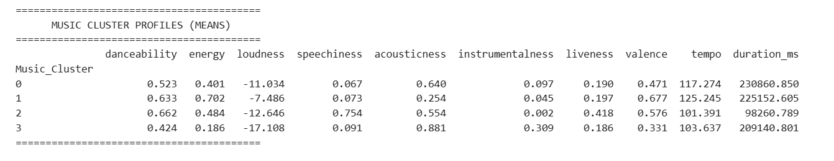
Cluster analysis image.

After this, I created four visualisations to see how the songs are clustered, for this I have done a scatter plot and a bar plot, heatmap and a kdeplot as shown here.
Plot 2.
Plot 1.
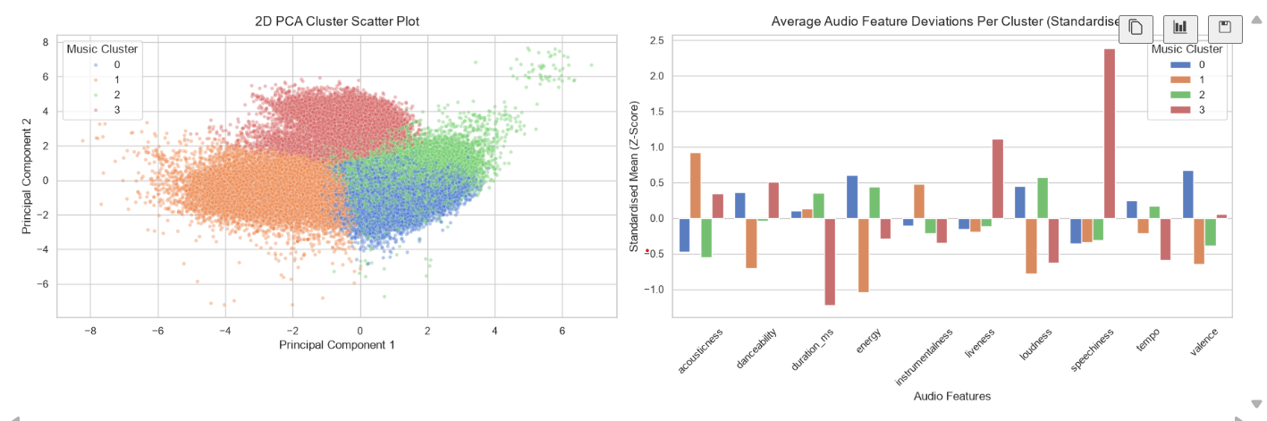

From plot 1, we can see that the clusters show well-defined, distinct spatial boundaries with minimal mixing. This visually validates that choosing 4 clusters provides a clean partition of the data where the clusters are grouped nicely with a few clusters far away in the lightgreen cluster, this highlights a small group of tracks with a hyper-specific sound profile that completely isolates them from mainstream patterns.

From plot 2, we can see that cluster 0 blue cluster has high energy these relate to the songs which are high energy, high loudness, above-average tempo, and high valence for example: pop genre. The next cluster orange 1 shows a high negative z-score which means slow, with high acousticness combined with very low energy, low loudness, and below-average danceability, for example: ambient genre. The next cluster 2 green shows above-average duration_ms (longer runtime), higher instrumentalness, and very low danceability, for example: rock genre and finally the last cluster 3 red shows a very large value in speechiness, high danceability, high liveness, and low duration_ms for example: hip-hop.

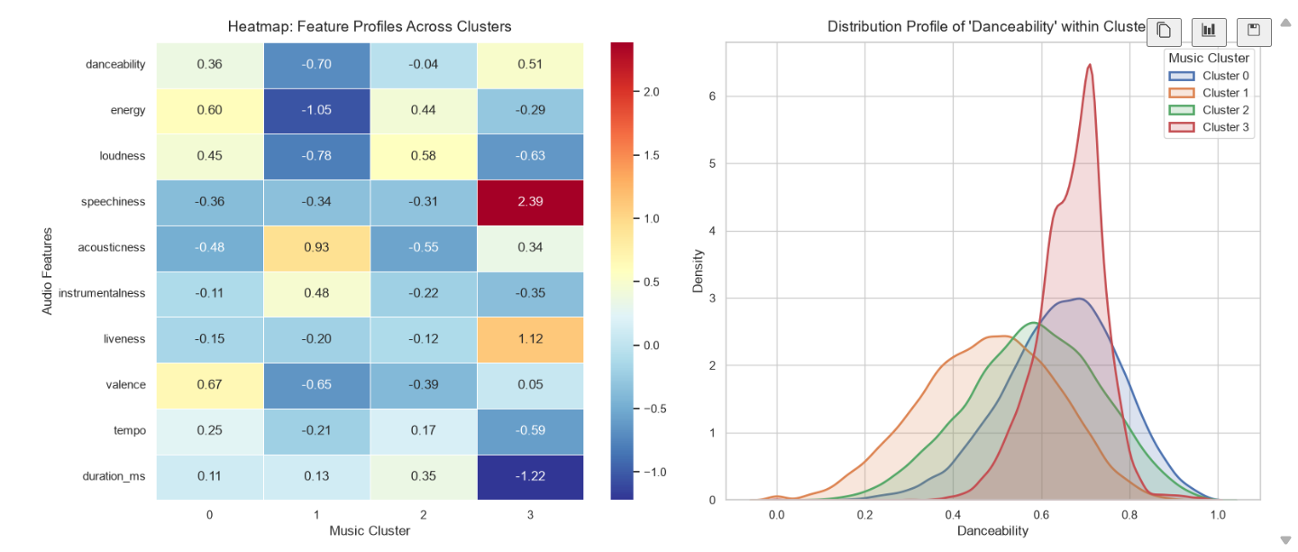
kdeplot
heatmap

From the heatmap, the 0.0 mark on the heatmap's colour bar represents the dataset average. Red/warm tones indicate features well above average, while blue/cool tones indicate features well below average. For example, if we take cluster 0, it has strong positive values for valence (0.67), energy (0.60), and loudness (0.45). It has a negative score for acousticness (-0.48). This confirms a bright, loud, electronic or highly produced pop/rock sound.

From the kdeplot, we can see the spread, peak, and consistency of the danceability feature across individual songs in each cluster group, for example: cluster 3 the red curve which is tall and has a peak around 0.7 which means that almost every single song sorted into cluster 3 has a guaranteed, consistently high danceability factor. There is very little variation.

My streamlit application for this project:
This is my streamlit app, where my streamlit app consists of two pages – one is the homepage and the other is the song discovery page which I built using the K-means algo, DBSCAN and PCA methods where the user can search for the song they like based on popularity, genres, song name and artist name, each song is being clustered into different groups from which the user can choose either chill acoustic or energy hyped or groove rhythmic or melodic deep ambient.
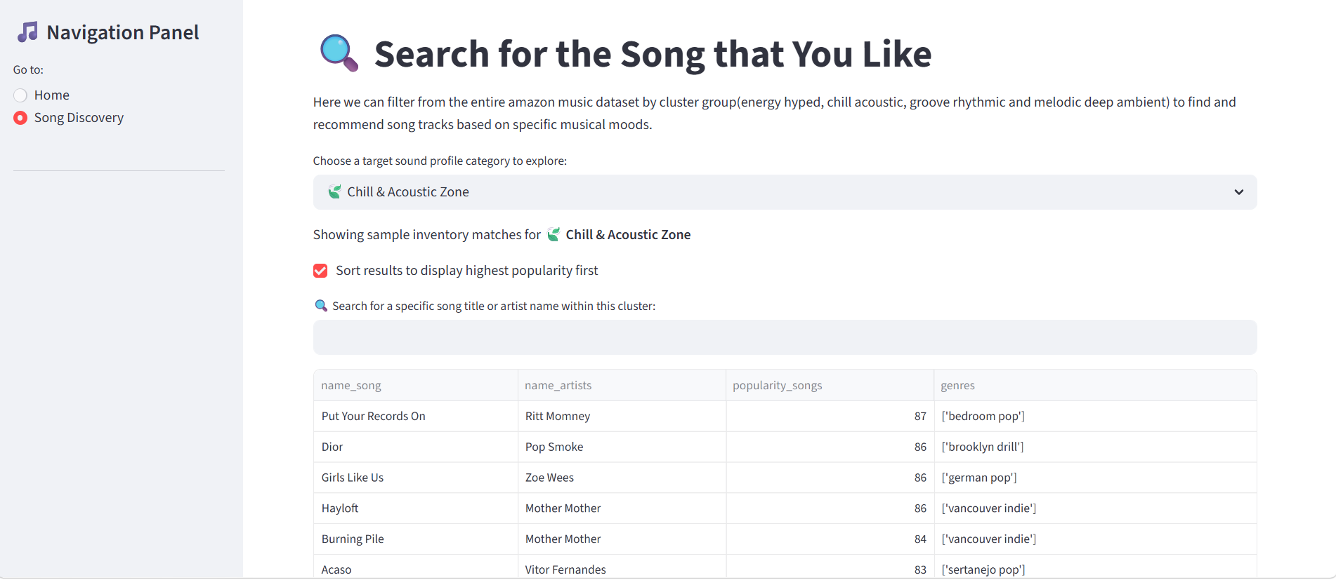
here the user can select to display the results by highest popularity first.
Can use the drop-down menu to choose the song.
Can search for the song by typing the song name here.

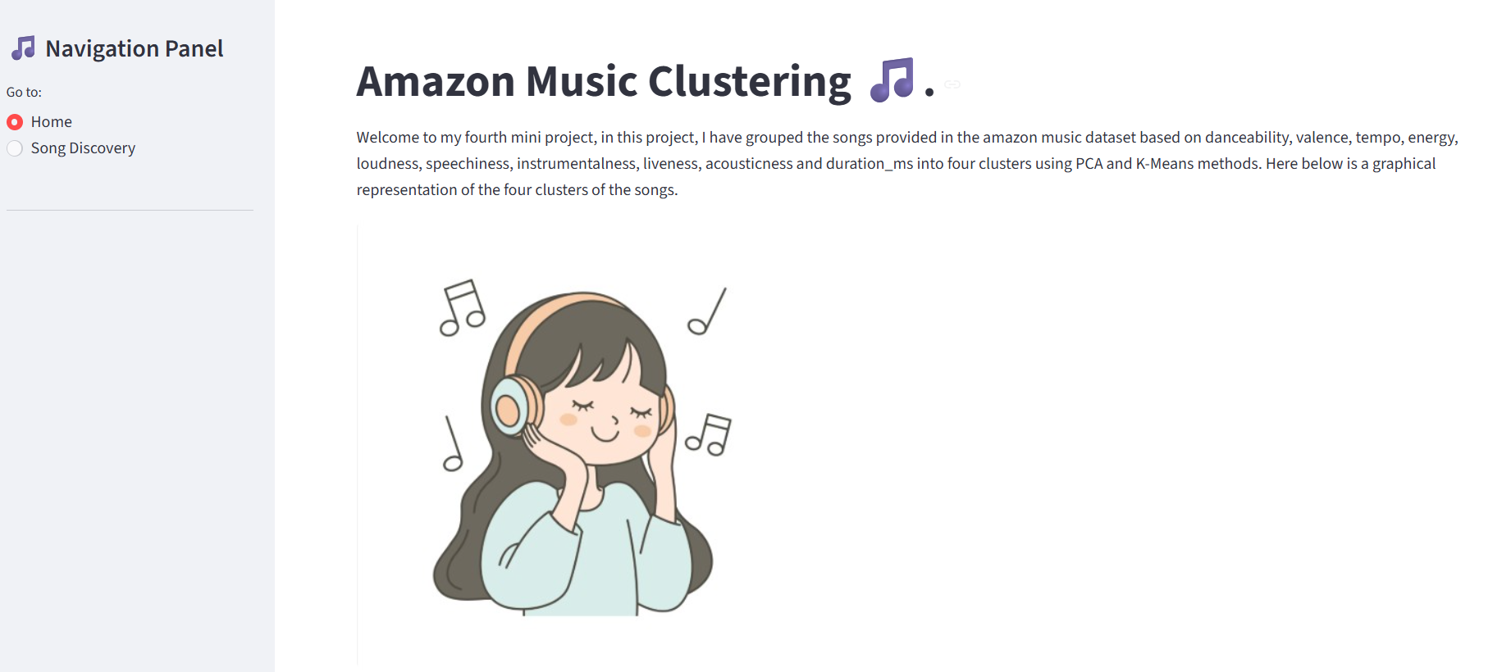
This is my homepage part of my streamlit.

